Steps Towards an Intelligent Firewall – A Basic Model

Ulrich Ultes-Nitsche and InSeon Yoo

telecommunications, networks & security Research Group
Department of Informatics
University of Fribourg

Chemin du Musée 3
CH-1700 Fribourg
Switzerland
e-mail: uun@unifr.ch and in-seon.yoo@unifr.ch
http://diuf.unifr.ch/tns
phone: +41 / (0)26 / 300 91 49 and +41 / (0)26 / 300 84 68

ABSTRACT In this paper, we discuss our ongoing research in the area of intelligent firewall technologies. An intelligent firewall inspects not only the header but also the payload of an arriving data packet and aims at deciding intelligently whether or not the packet contains potentially malicious content. Based on the estimation of a packet’s maliciousness (a probability estimation related to some attack scenario) and using the particular security policy of the protected network, the data packet will then either be dropped or it passes through the firewall. We propose an architecture model of an intelligent firewall in this paper, focussing on prevention against viruses and worms crossing the network boundary.

KEY WORDS Firewalls, Intelligent Packet Inspection, Malicious Code Detection
Steps Towards an Intelligent Firewall – A Basic Model

- INTRODUCTION

Classical packet-filtering firewalls [1] inspect a data packet’s header and decide whether or not to let the packet enter a network. The decision is based on header information (such as higher-level protocol information, IP addresses and port numbers, etc.). Packet filters allow closing the “entrance” to a network except for some very specific entry points. As they do not analyse the payload, i.e. the content of data packets, they cannot tell whether data entering the network through an open address/port can potentially be harmful. There exist more elaborate firewalls, such as stateful firewalls [1], which are far less frequently used in practice and which still are not aiming at inspecting packet payload for malicious content.

Our current research focuses on extending the functionality of a packet-filtering firewall with payload inspection features. Since part of the decisions to be made by the firewall will be based on incomplete knowledge and require the application of artificial intelligence (AI) techniques, we have labelled the resulting firewall intelligent. To date we have considered in particular how payload inspection can be applied to virus and worm detection, which we refer to as malicious packet detection. We do believe strongly in the benefits of trying to stop malicious code as early as possible, i.e. even before it enters the network, namely at the level of a firewall. The intelligent firewall (IFW) will not only aim to detect known malicious code in data packet content, but it will also prevent against new unknown viruses.

We present in this paper an analysis of known viruses that we undertook exhaustively (Section 2). Based on the virus features found in this analysis we believe that we can detect (some) novel viruses by application of AI techniques to the inspection of data packets’ payloads. We present the AI techniques that we identified as applicable to the IFW in Section 3, in which a packet-based classification engine as well as a smart detection engine is described conceptually. In Section 4 we discuss how the above-mentioned engines can be integrated into a whole system by presenting the architecture model of the IFW. It is important to note that our research on the classification and detection systems is in an early stage so that details may change. However, we envisage the entire concept of the IFW as presented in this paper to be very stable and do not expect any major conceptual changes in the future.

- ANALYSIS OF VIRUS DATA

In this section, we discuss several viruses/worms that occurred over the recent years. We discuss their basic behaviours as well as their specific features that allow us to identify them. Prior to that, we discuss briefly virus statistics we have analysed.

  - Some facts about viruses
According to Computer Virus Incident Reports [2] for May 2002, compiled by the Information-technology Promotion Agency Security Center (IPA/ISEC), the total number of reports for the first half of 2002 was 1.2 times greater than that of last year. Moreover, the major reported viruses propagated via e-mail, and the top 2 viruses were spread by exploiting security holes.

According to virus statistics based on the Virus Information Database [3] of Ahnlab, about 80% of Windows file worms were transferred via e-mail, and about 61% of these files were executables (.exe file extension). Most virus attacks have unselective targets. We discuss two types of blind targeting: social engineering attacks and security vulnerability attacks. In this section, we focus on the deployment of viruses rather than the detection of viruses in infected systems. We explore how they spread before a machine is infected and, after a system is infected, how viruses distribute themselves to other machines. Viruses have specific characteristics, which can be used to detect them whilst they process their propagation.

  - Social engineering attacks
Social engineering is hacker terminology for tricking unaware users into downloading and executing malicious software received via e-mail, Internet relay chat or instant messaging.

    - W32/SirCam
It spreads through e-mails and potentially through unprotected network shares [4]. Once the malicious code has been executed on a system, it may reveal or delete sensitive information. The virus appears in an e-mail message written in either English or Spanish with a seemingly random subject line. The e-mail message contains an attachment whose name matches the subject line and has a double file extension (e.g. subject.ZIP.BAT or subject.DOC.EXE). The second extension is .EXE, .COM, .BAT, .PIF, or .LNK. The attached file contains both the malicious code and the content of a file copied from an infected system. In addition, this worm includes its own SMTP client capabilities, which it uses to propagate via e-mail. It determines its recipient list by recursively searching for e-mail addresses contained in all *.WAB (Windows Address Book) files. As a result, its propagation via mass e-mailing can cause denial of service (DOS) conditions.

    - W32/MyParty
This virus is written for the Windows platform. It spreads as an e-mail attachment [5]. The attached file name is www.myparty.yahoo.com, which can cause the web browser to run unexpectedly. “.com” is both an executable file extension in Windows and a top-level Internet domain. The payload contained in W32/MyParty is non-destructive. When this virus is executed, an e-mail message is sent to a predefined address with a subject line of the folder where the W32/MyParty malicious code has been stored on the victim’s host. When this message is sent, the SMTP statement HELLO HOST is used by the malicious code to identify itself to the SMTP server. Meanwhile, the hard drive is scanned for *.WAB files, Outlook Express indexes and folders (.DBX) in order to harvest e-mail addresses. Copies of the malicious code are then e-mailed to all the e-mail addresses found. This step of mass mailing may be time-dependant. Targeted sites may experience an increased network load on the mail server when the malicious code is propagating.

    - VBS/LoveLetter
This worm is created in VBS (Visual Basic Script language) and spreads in a variety of ways; e-mail propagation, Windows file sharing, Internet relay chat (IRC), USENET news, and possibly via web pages [6]. It arrives via e-mail and is activated by a double click on the message attachment called LOVE-LETTER-FOR-YOU.TXT.vbs. This worm attempts to send copies of itself using Microsoft Outlook to all the entries in all the address books. When the worm executes, it attempts to create a script file to send a copy of the worm via DCC (Direct Client Communication) to other people in any IRC channel joined by the victim. This worm also uses the Windows file sharing systems: When the worm executes, it searches for certain types of files and replaces them with a copy of itself.

  - Security vulnerability attacks
Currently security holes which viruses misuse are mostly related to Microsoft software, such as Internet Information Server (IIS), Windows NT, Windows 2000, Outlook Express, and Windows Internet Explorer.

    - Code Red/Code Red II
The Code Red/Code Red II is a self-propagating worm [7] misusing Microsoft's Internet Information Server (IIS), affecting network performance. The Code Red/Code Red II worm attempts to connect to port 80/tcp on a randomly chosen host assuming that a web server will be found. Upon a successful connection to port 80, the attacking host sends a crafted HTTP GET request to the victim, attempting to exploit a buffer overflow in the indexing service. This HTTP GET request is sent to chosen hosts aiming at self-propagating the worm. If the HTTP request is successful, the worm can be executed on the victim’s host. The Code Red II copies CMD.EXE to root.exe in the IIS scripts and MSADC folders. Placing CMD.EXE in a publicly accessible directory may allow an intruder to execute arbitrary commands on the compromised machine with the privileges of the IIS server process. Then the worm creates a Trojan horse as a copy of explorer.exe and copies it to the C: and D: drive. On systems which are not patched against the relative shell patch [8] vulnerability, this Trojan horse runs every time when a user logs in the system. (Microsoft has released a patch that eliminates this security vulnerability in Microsoft Windows NT 4.0 and Windows 2000. Under certain conditions, the vulnerability could enable an attacker to cause code of his choice to run when another user subsequently logged into the same machine.)

The beginning of the Code Red's attack packet looks as follows [9,10]:
GET/default.ida?NNNNNNNNNNNNNNNNNNNNNNNNNNNNNNNN
NNNNNNNNNNNNNNNNNNNNNNNNNNNNNNNNNNNNNNNNNNNNNNNNNNN
NNNNNNNNNNNNNNNNNNNNNNNNNNNNNNNNNNNNNNNNNNNNNNNNNNN
NNNNNNNNNNNNNNNNNNNNNNNNNNNNNNNNNNNNNNNNNNNNNNNNNNN
NNNNNNNNNNNNNNNNNNNNNNNNNNNNNNNNNNNNNNN%u9090%u6858%ucbd3

    - Nimda worm
The Nimda worm affects both user workstations (clients) running Windows 95, 98, ME, NT or 2000 and servers running Windows NT and 2000 [11]. The worm modifies web documents (e.g. .htm, .html, and .asp files) and certain executable files found on the systems it infects, and creates numerous copies of itself under various file names. One part of the Nimda worm's attack packet looks as follows [12]:
GET /scripts/root.exe?/c+dir
GET /MSADC/root.exe?/c+dir
GET /c/winnt/system32/cmd.exe?/c+dir
GET /d/winnt/system32/cmd.exe?/c+dir
....................

The Nimda worm uses three ways of propagation. First is e-mail propagation: The worm propagates through e-mail messages consisting of two sections, a blank message and an executable attachment. The first section is defined as MIME (Multipurpose Internet Mail Extensions) type text/html, but it contains no text, so the e-mail appears to have no content. The second section is defined as MIME type audio/x-wav, but it contains a base64-encoded attachment file readme.exe, which is a binary executable. Due to a vulnerability of Microsoft Internet Explorer to start the HTML mail automatically, the enclosed attachment can be executed and, as result, infects the machine with the worm. Even though this worm is promulgated through e-mail, the infected machine provides a copy of the worm via a web server or the file system because the executable file modifies all web content files in the system.

The second way of propagation is browser propagation: Nimda modifies all web content files it finds. As a result, any user browsing web content on an infected system may download a copy of the worm. Finally, the third way is file system propagation: The Nimda worm creates numerous copies of itself in all writable directories to which the user has access. If a user on another system subsequently selects the copy of the worm file on the shared network drive, the worm may be able to compromise that user’s system. Nimda can cause bandwidth denial of service (DOS) conditions on networks with infected machines.

    - W32/Klez-H
This worm contains a compressed copy of the new variant of the W32/Elkern virus, which is dropped and executed when the worm is run. It is quite similar to the other variants of this dangerous virus. It searches for e-mail address entries in the Windows address book, in ICQ list and in the files on the disk. It uses its own mailing routine. The worm attempts to use the well-known MIME security hole in the MS-Outlook, MS-Outlook Express, and Internet Explorer to run the attachment automatically. Infected e-mails have some characteristics: the subject line is either random or is composed from several strings, the body text is either empty or composed randomly, and the attached file has a random name with extension .PIF, .SCR, .EXE or .BAT.

  - Virus patterns in infected files
We consider patterns in the format of infected files in this section rather than the virus itself. Recall that a virus is a piece of code that infects several files and changes their form as an effect of the infection. By and large, viruses consist of a virus program as well as several auxiliary files and information, which support the virus program to spread smoothly. Once the virus program infects several files in a single system, existing files contain a piece of virus code and will be spread as another infected virus program. Subsequently, we examine the structure of programs infected by different types of viruses.

    - Parasitic viruses
Parasitic viruses are viruses, which have to change the content of target files while transferring copies of themselves. The infected files remain completely or partly usable. There are three types of such viruses: prepending viruses store a copy of themselves at the top of a file, appending viruses copy themselves to the end and inserting viruses insert themselves somewhere in the middle. The insertion method may also vary by moving a fragment of the file towards the end of file or by copying virus code to parts of the file, which are known to be unused. The most common method of virus incorporation into files is by appending the virus to the end of file. In this process the virus changes the top of file in such way that the virus code is executed first. This is a simple and usually effective method as the developer of the virus does not need to know anything about the program to which the virus will append itself and the appended program simply serves as a virus carrier [13]. In DOS .com files, this is achieved in most cases by changing the first three or more bytes of the instruction code to the address of the routine passing control to the body of the virus as in Figure 1.

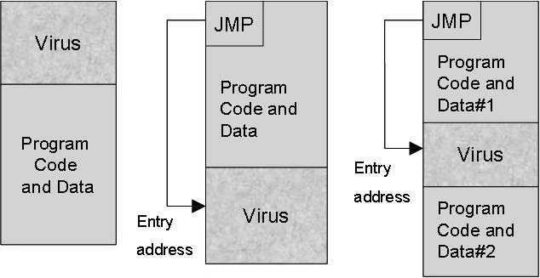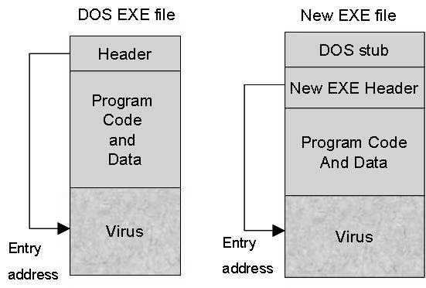

Figure 1. Virus positions in .com and .exe files.

    - File worms
File worms are a modification of companion viruses, but unlike them they do not connect their presence with any executable file. (Companion viruses do not change the infected files. Their operation is to create a clone of the target file, so that when the target file is executed, its clone virus gets the control instead.)

When worms distribute themselves, they just copy their code to some other disk or directory, in the hope that a user will execute the new copies some day. Sometimes worms give their copies a special name in order to push the user into running the copy, e.g. INSTALL.EXE or WINSTART.BAT.

There are worms, which use rather unusual techniques; for instance they add their copies to archives (ARJ, ZIP and others). Such worms are for example ArjVirus and Winstart. Some other worms insert the command starting the infected file into BAT files.

    - Macro viruses
Macro viruses are programs written in macro languages built into some data processing systems such as Microsoft Word, Microsoft Excel spreadsheets, etc. To propagate, such viruses use the capabilities of macro languages and with their help transfer themselves from one infected file, e.g. a document or spreadsheet, to another. Macro viruses for Microsoft Word, Microsoft Excel and Office97 are the most common ones. Figure 2 shows the location of macro viruses.

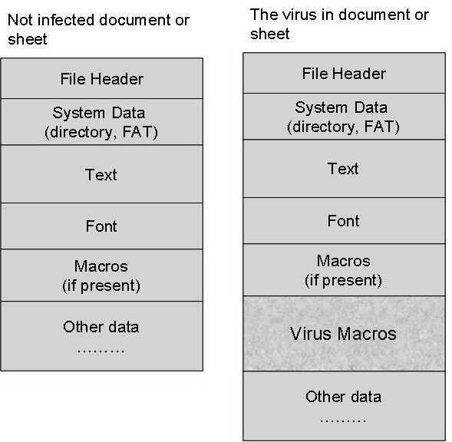

Figure 2. Macro virus position in an infected document.

- CLASSIFICATION AND DETECTION

The analysis presented in the previous section has shown that malicious code possesses very specific features that enable us to identify it. For known malicious code these so-called signatures are used in anti-virus software. We believe that future occurrences of (novel) malicious code will also possess very specific features. We additionally believe that we can identify novel malicious code transported in data packets by analysing these data packets. First experiments with capturing and analysing data packets have increased our confidence in the possibility of protecting networks against novel virus/worm attacks. In this section, we present the techniques we identified as applicable to the IFW.

First of all, we will classify packets into different classes of their potential maliciousness. We do this by assigning to each data packet a probability that estimates the likelihood of the packet to contain malicious content. This classification is based on a structural analysis of data packets. The structural analysis is mainly concerned with information that can be obtained from a packet’s header. After the classification step a detection step can follow. The detection step will be executed if the classification step could not assign a probability such that, based on a given policy, the packet could be classified without (major) doubt as either malicious or benign, or if the position of a virus in a packet belonging to a probably infected file should be found. So the detection does both, improve the results of the classification step (if necessary) and locate potentially malicious content.

To classify data packets based on structural information, we decided to use a Bayesian network. A Bayesian network [14] is simply a graphical representation of probabilistic dependencies that will help us to calculate conditional probabilities of the potential maliciousness of packet content based on observed evidences (here the evidences are structural information about the packet). For example, the Bayesian network will help to answer a question like: “What is the probability that a packet contains malicious content if it is an SMTP packet (e-mail packet) that is part of a MIME-encoded file that has a double file extension and is executable?” (In this particular case, the probability is high that the file it is part of is an Internet worm.) Figure 3 shows an example of a Bayesian network for the classification of SMTP packets. An arrow from a parent node to a child node represents the conditional probability of the potential maliciousness of an SMTP packet when observing the evidence represented by the child node, under assumption that the condition described by the parent node holds. Applying the Bayesian network of Figure 3 to each SMTP packet reaching the IFW, a probability of being malicious will be assigned to each packet. We have named the IFW component that implements this probability assignment the packet-based classification engine. A security policy will then tell whether to drop the packet, let it pass, or feed it into the detection part.

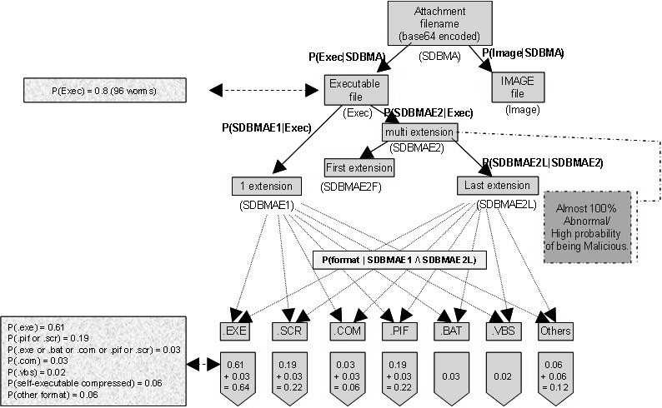

Figure 3. A Bayesian network to classify SMTP packets.

For the detection part we envisage using a neural network. Since we do not believe that we will get good enough training data to train a neural network in a supervised fashion, we are currently considering applying a neural network concept that is capable of unsupervised learning (“it makes its own experiences”). Working conceptually on what we call the smart detection engine is our current major research focus in the IFW project Janus. Even though the final decision on the neural network model has not been made yet, we hope that the self-organising map (SOM) will be suitable to be applied to the smart detection engine of the IFW. In the SOM potentially multi-dimensional input (various aspects of the payload of a data packet) will be projected onto a two-dimensional layer of neurons, the so-called Kohonen layer. The neurons in the Kohonen layer compete for input and, over time, learn what is “good” input for them. We will aim to design the SOM [15] in such a way that neurons will flag the presence of peculiar patterns in data packets in such a way that the position of the active neurons will reflect the position of potentially malicious content in the packet. Even though we have thought this through very thoroughly, the detection part of the IFW is very much work in progress and possibly subject to alteration based on results we will get from experiments with different detection approaches.

- THE IFW ARCHITECTURE MODEL

We have implemented packet-capturing software based on the libpcap library [16]. On the decoded version of the captured packets (for decoding the packets we use SNORT [17]) we currently can run a packet analysis (incoming e-mail packets). Using a Bayesian network, we analyse certain packet characteristics that allow us to attach to packets probabilities of their maliciousness. The Bayesian network we have currently considered can classify packets of the SMTP protocol. Responsible for performing this step is the packet-based classification engine. To define the parameters of the Bayesian network we have exhaustively analysed file characteristics of virus attachments to e-mails. The second engine in our model, the smart detection engine, will be fed with packets pre-filtered and classified by the classification engine. The smart detection engine will analyse the payload of the packets it is provided with and aim to detect anomalous patterns in the payload. To do so, it will exploit AI techniques, namely neural networks, and compare packet payloads with what it perceives as normal/anomalous content. In contrast to the packet-based classification engine, we have not yet made any practical experiments with the smart detection engine.

Finally, the policy interpreter will analyse the information it gets from the two engines and will decide on whether to drop a packet or let it pass through the firewall based on a packet’s probability to contain malicious content and a specific security policy that rules the policy interpreter’s decisions. The complete IFW architecture model is depicted in Figure 4.

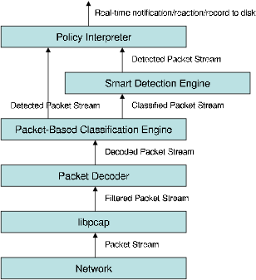

Figure 4. The IFW architecture

- CONCLUSIONS AND FUTURE WORK

We have discussed an architectural model of an intelligent firewall in this paper. The purpose of this firewall is to complement standard packet-filtering functionality with an intelligent inspection of a data packet’s payload, aiming at preventing malicious code from entering the protected network at all. Besides filtering and decoding the packet stream, the intelligent firewall architecture that we propose contains a packet-based classification engine, a smart detection engine, and a policy interpreter. With the help of the two engines, a probability of containing malicious code will be assigned to each data packet, including a possible location of the malicious content, and finally the policy interpreter will decide whether to drop a packet or let it pass based on a given security policy. To perform these tasks the intelligent firewall will exploit AI techniques. We have identified Bayesian networks and self-organising maps as suitable techniques for the classification and detection parts respectively.

The intelligent firewall is not envisaged to replace other security systems but rather complement them. It is unlikely that it will be capable of filtering out all malicious code at the network boundary. Viruses may still pass through the firewall undetected and hopefully be detected by another security system in the network or on individual network nodes. We aim to develop a system that reduces the amount of malicious code reaching nodes within the network.

As there is an obvious trade-off between the necessary speed of the detection procedure to deal with real-time network traffic and the accuracy of the detection, a major technical issue of our future work will be developing a well-performing system that produces a low rate of false positives. Furthermore, we hope that the techniques we apply to the detection of malicious code can in an adapted form be applied to intrusion detection. Therefore we plan to investigate how the intelligent firewall could co-operate with an intrusion detection system (IDS) to increase the effectiveness of the IDS. This is, however, future work.

- REFERENCES

- John Wack, Ken Cutler, and Jamie Pole. Guidelines on Firewalls and Firewall Policy. NIST (National Institute of Standards and Technology), Special Publication 800-41,January, 2002.
- IPA/ISEC. Computer Virus Incident Reports. Information-technology Promotion Agency Security Center (IPA/ISEC), Online Publication, May, 2002.
- Ahnlab. Virus Information. Ahnlab.Inc., Seoul, Korea, August, 2002.
- CERT/CA-2001-22. CERT Advisory CA-2001-22: W32/Sircam Malicious Code. Online Publication, July, 2001.
- CERT/IN-2002-01. CERT Incident Note IN-2002-01: W32/Myparty Malicious Code. Online Publication, January, 2002.
- CERT/CA-2000-04. CERT Advisory CA-2000-04: Love Letter Worm. Online Publication, May, 2000.
- CERT/CA-2001-23. CERT Advisory CA-2001-23: Continued Threat of the Code Red Worm. Online Publication, 2002.
- MS00-052. Microsoft Security Bulletin/MS00-052. Online Publication, July, 2000.
- CERT/CA-2001-19. CERT Advisory CA-2001-19: Code Red Worm Exploiting Buffer Overflow In IIS Indexing Service DLL. Online Publication, July, 2001.
- CERT/IN-2001-09. CERT Incident Note IN-2001-09: Code Red II: Another Worm Exploiting Buffer Overflow In IIS Indexing Service DLL. Online Publication, August, 2001.
- CERT/CC. Overview Incident and Vulnerability Trends. Online Publication, April, 2002.
- CERT/CA-2001-26. CERT Advisory CA-2001-26: Nimda Worm. Online publication, September, 2001.
- Charles P. Pfleeger. Security in Computing. International Edition, Second Edition, Prentice-Hall International, Inc., 1997.
- Judea Pearl. Probabilistic Reasoning. In: Intelligent Systems: Networks of Plausible Inference. Morgan Kaufmann Publishers, Inc., San Mateo, California, 1988.
- T. Kohonen. Self-Organizing Maps. Springer, Berlin, Heidelberg, 1995.
- TCPDUMP/LIBPCAP. The Tcpdump Group, 2002.
- SNORT: The Open Source Network Intrusion Detection System. 2002.

