INFOSURE: AN INFORMATION SECURITY MANAGEMENT SYSTEM

D. P. Venter
dirkv@webmail.co.za
Prof. SH von Solms
basie@rkw.rau.ac.za
RAU-Standard Bank Akademie vir Inligtingstegnologie
Johannesburg

ABSTRACT

The development of InfoSure, an information security management system prototype, was based on currently available applications, as well as incorporating the need for cost-effectiveness, flexibility, and expandability. This shifted the focus from attempting to provide a comprehensive list of interfaces and measurements into general information security related activities, to providing a generic tool that could be customised to handle any information fed back to it. The measurements could then be custom developed to suit the needs of any organisation.
InfoSure provides a flexible central management console and allows an organisation to develop custom measurements and monitoring services, entities and rules. This is in contrast to current enterprise security management solutions that are restrictive in their customisation abilities, but offer a comprehensive range of pre defined information security measurements.

KEY WORDS
Information Security, Management System
INFOSURE: AN INFORMATION SECURITY MANAGEMENT SYSTEM

Introduction

InfoSure, as the prototype is named, was developed to test the feasibility of an information security management system that improves on what currently is available. The areas in which the proposed system will provide the most benefit will be in the rich cross entity rules functionality and cost effective implementation that is both extensible and expandable to the needs of an organisation.

The system provides a centralized management console to which custom developed measurement services can feed back results and information, allowing an ISO to evaluate this information and initiate appropriate responses. These measurement services include any custom developed application or code which monitors processes and events related to information security as defined in the information security policy. They should be able to run according to a predefined schedule, and be able to return their results to the management system for interpretation.

The current InfoSure system was designed to run on the Microsoft platform using Microsoft technologies. The example monitoring services provided are aimed at information security risks in the Microsoft NT environment, however the structure and logic of the design should prove applicable in other operating environments as well. The generic entities functionality is not Microsoft specific, and can be applied to any security related entities that the ISO wishes to monitor.

Key Requirements

The prototype was developed as a feasibility study into improving on current information security management systems, with particular attention to expandability, extensibility and rules functionality. The system needed to prove cost effective to implement, and was designed around several key requirements. The system’s aim was to implement the following:

- Be governed by information security policies
- Provide active feedback and monitoring
- Provide active management (Auto enforcing)
- Be expandable
- Be extensible
- Allow for predefined and custom developed measurements
- Make use of generic entities
- Be centrally managed
- Implement cross measurement rules
- Be user friendly

dESIGN pRINCIPLES EMPLOYED

Open standards
Open standards were used for the design of the system application programmable interfaces (APIs), as well as the transfer of the measurement service information to the system. The APIs were designed to accept Extensible Mark-up Language (XML) messages [W3C 2002], which describe the state of the monitoring process or program and the state of the measured entity.

The messages are transferred to the system via the commonly used hypertext transfer protocol (HTTP) [W3C 2000]. This also allows for HTTPS to be used in scenarios where sensitive information will be transferred to the central system, and security is of importance.
The result of these design elements is a system that allows for the development of multi-platform services that can still return information to the central management system, irrespective of platform.

Dynamically generated data fields
Additional fields can be added dynamically to the system in a number of areas. This facility, available from the administrative sections of the system, provides the means with which to extend the information gathered by measurement services. This offers added flexibility to both the system administrator and the developers of the services by enabling the passing of additional information across the network to the management system.

A high level of user configuration
Almost all aspects of the system are totally user configurable and the system administrator has full control over all the status codes to be used.

Measurement service APIs
The API of the InfoSure system is based on passing XML messages to relevant URLs via HTTP. As discussed before, these URLs then parse the XML and update the central management system. Currently, the parsing is done using active server pages, or ASP, and the Microsoft XML document object model (DOM), but theoretically could be any application that can be invoked via an HTTP call and accept XML messages. This would also allow a more secure interface. A dynamically linked library (DLL), for example, would be more difficult to modify than the interpreted ASP code and thus improve its security.

A rules engine
InfoSure allows an administrator to define sets of rules (which could be based on the organisation’s security policy) to determine actions to take when certain specified states are returned by any of the measurement services. Rules comprise a number of individual rule items, which combine to form rule elements, which in turn can be combined to create complex sets of logic. These elements and items are combined using the OR and AND Boolean logic operators.

Once a rule has been broken, an associated event can be initiated. Events are predefined sets of actions to be taken. Additionally, tolerance levels can also be built into the rule evaluations.

A practical example would be a case where a system administrator needs to be notified if any user, who does not have the necessary permissions, tries to log on to the network. In this scenario, the rule would state that if a monitoring agent returns a status indicating a network access violation, then an action (event) is kicked off. In this case the event would be e-mail to the administrator.

Because the rules engine also allows for more complex rules involving Boolean logic and different activity measurements, the scenario can be further expanded to include additional checks (see figure 5). The rule in the scenario above can be modified to only notify the administrator of unsuccessful access attempts where the user is also on leave. A separate monitoring agent would return information regarding leave status to the central management system.

User on leave
Login attempt failed 3 times
AND

Notify Administrator

Figure 1. Example of a rule in InfoSure
These rules are also used to generate dynamic reports. The report would display a listing of all the entity instances that have failed the rule’s check. ISO is able to limit this listing to certain date ranges of occurrence.

Web based design
The system’s user interface is browser based, and was developed using active server pages (ASP), running on Microsoft’s IIS 5.0 web server software [MIC 2001]. This browser-based approach allows users of the system to log in from any computer on the network, or even over the Internet.

Generic entities
The system allows for custom defined and configured entities. Entity types, such as users, can be created and entity field attributes assigned to each type. ‘User’ for instance would typically have attributes such as employee number, first name, last name, etc. One of these attributes will need to be flagged as the key. This would then be used to uniquely identify instances of each entity type. In terms of a user entity, this would most likely be the employee number.
The information relating to instances of these entities can be entered into the system either by means of the browser-based front-end, or by making use of specifically defined APIs. These APIs allow for the maintenance of these entity instances to be automated. There are also APIs defined to handle status updates of activities related to these instances. An example would be the logging of remote accesses to the network.

Custom event scripts

Custom scripts can be created for execution based on the outcome of rules and feedback information. This is accomplished by making use of the Microsoft Windows Scripting Host [SHU 200], a language-independent scripting host for 32-bit Windows platforms. Windows Scripting Host enables scripts to be executed directly on the Windows desktop or command console, without the need to embed those scripts in an HTML document. The scripts themselves can in turn instantiate other component object model (COM) components and execute methods and functions of those components.

Conceptual diagram of infosure

InfoSure Management Centre

Web Site

C

InfoSure API
B
Database
A

Server
InfoSure Measurement 1
InfoSure Measurement 2
E
F
Entity Information Updates
Entity Status Updates
H
Rules Engine
Script
Engine
J

I

D

G

Figure 2. Conceptual diagram of the Prototype Information Security Management System

A InfoSure database, which houses all information security related information passed to the system, either via the web front-end, or via the APIs.

B InfoSure Management Centre, which forms the focal administrative point of the system. Information fed back or into the system is processed here.

C Part of the InfoSure management centre consists of a graphical interface to the user through which measurements and other system information pertaining to the system is presented. In this case the interface is web browser based.

D The API layer, through which communications to and from external measurement, monitoring and other updateable services occur. The XML standard over an HTTP protocol is used.

E Measurements 1 and 2 represent service modules or agents that are plugged into the InfoSure network environment. Each module would provide a different set of measurements to the system, and is designed to feed back information to the central InfoSure Management Centre. There can be any number of these modules, in any number of combinations on each server in the network. It should be possible to add these modules individually to a system running on any operating system.

F The ISO(s) can access the system for maintenance, reporting, etc. using a browser from any workstation that is connected to a network that can see the web site.

G This represents the custom developed code that an organisation can use to manage instances of custom developed entities in the central system (for example, the adding of users).
H This represents the custom developed code that an organisation can use to update
the status of its custom defined entities in the central system. These status updates would indicate activity related to the entities, which would be of use to the ISO in managing adherence to the organisation’s policy document.

I The rules engine, which can be used to evaluate activity information fed back to the central management system.

J Based on the outcome of activity feedback evaluation by the rules engine, it is also possible to fire an event by making use of the scripting engine. This engine basically provides a shell within which custom code can be executed on the management server, by using Visual Basic script. Using this engine, e-mails can be generated, system settings changed, etc.

hYPOTHETICAL sCENARIOS

To demonstrate the use of InfoSure, we will construct a hypothetical situation for organisation XYZ, and then provide the solutions that can be implemented using InfoSure.

Suppose that organisation XYZ has a security policy, and they want to start enforcing it and monitoring compliance. The policy contains statements that lends itself to automated monitoring and enforcement, and can be grouped as follows:

- Non-entity specific policy statements: These are statements that are not applied to any entity specifically, but instead apply to all entities within a type. An example of this is strong passwords. It applies to all users.

- Entity specific policy statements: These are statements that can apply to individual or to subsets of entities. An example of this would be a statement regarding RAS access, which specific users or groups of users are granted permission to utilize.
Table 1: Extract of organisation XYZ’s security policy document

 | Policy Statement | Policy compliance Indicators
1 | Users must not have weak passwords | Passwords should not be:  - Words that are found in a dictionary.  - Common usage words.  - Words that form patterns (i.e. 12345)
2 | A register of all authorized remote access users will be maintained. | The contents of the register will be provided on a weekly basis to the ISO, who will then have to re-authorize the list.
3 | No one can access the network while on leave | No one can log onto the network with a user’s login while that user is on leave.

Table 1 represents extracts from organisation XYZ’s security policy document. Let’s examine each of the statements and compliancy indicators, and how they can be handled by the InfoSure system.

Strong Passwords
In this case the ISO can make use of an ‘Easy Password Cracker’ measurement service to check the passwords of users on a regular basis, and to feed the results back to the central InfoSure system. The ISO will be able to ensure that in cases where the service was successful (i.e. where a user was using a weak password) the appropriate administrator will be notified. This is accomplished by creating a rule similar to figure 3.

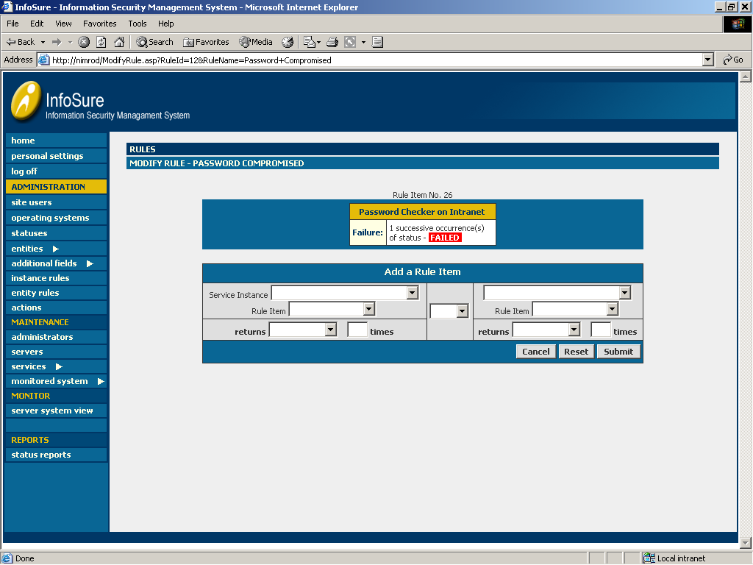

Figure 3. Screen shot of a rule set up in InfoSure

Register of authorised remote access users
The ISO can use the generic entities section of the InfoSure system to set up a ‘user’ entity type. Entity field options can then be added to this to represent, for instance, a unique employee number, name, surname, etc. as well as a field to indicate if the user is allowed remote access (see figure 4).
This can then be updated, either automatically using a feed through the relevant API, or manually by means of the web interface.
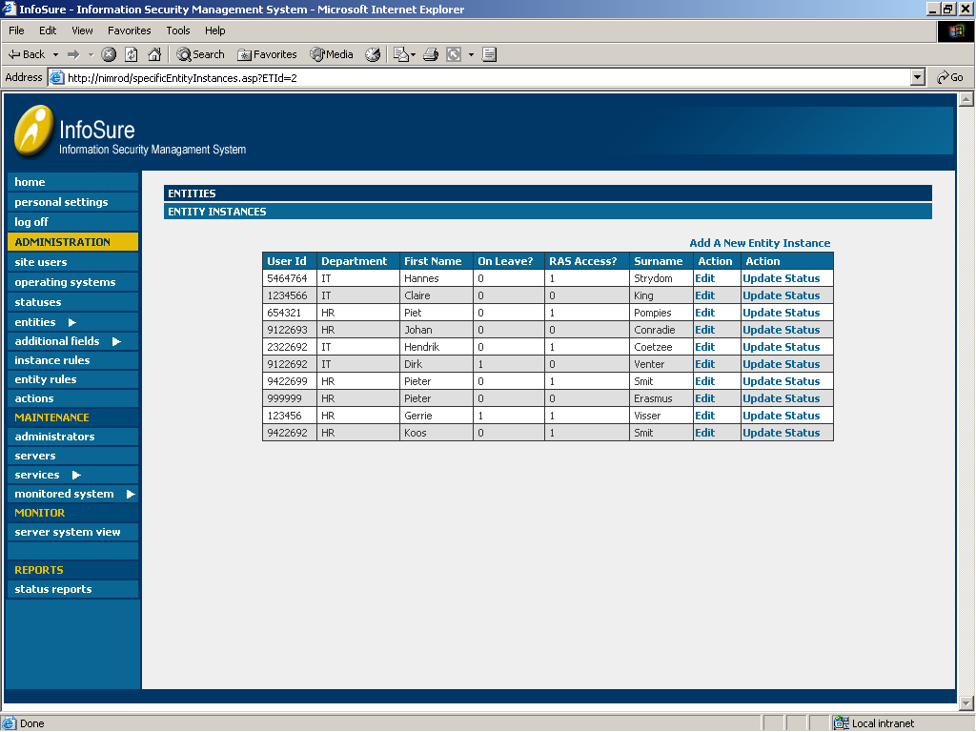

Figure 4. Screen shot of a user entity instances as defined in InfoSure

Users only allowed to use own logins
This can be accomplished by once again making use of an entity type of ‘users’. In this case it could contain an entity field option of ‘on leave’. This can then be kept up to date manually or via the appropriate API, as mentioned above.
Login information can be fed to the system using the normal service instance set-up. Using the rules, a check can be executed for each login attempt, to see if the associated user has been flagged as on leave or not. An appropriate action can then be initiated.

Figure 5. Screen shot of an entity rule as defined in InfoSure

Conclusion

The focus of InfoSure is on providing an application that allows an organization to grow and expand the system, as its information security management needs change. This contrasts to current enterprise security management solutions, which offer a comprehensive range of pre defined information security measurements and auto management, but at a price that puts it out of reach for organizations needing an entry level application.

6 REFERENCES

[MIC 2001] Microsoft Corporation. “Microsoft Windows 2000 Server Resource Kit: Supplement 1 Internet Information Services Resource Guide”
http://www.microsoft.com/windows2000/techinfo/reskit/en-us/default.asp?url=/windows2000/techinfo/reskit/en-us/w2rkbook/iis.asp , 2001

[SHU 2001] Shultz, G. “Taking Advantage of the Windows Scripting Host”
Windows Professional. http://msdn.microsoft.com/library/default.asp?url=/library/en-us/dnwinpro00/html/WindowsScriptingHost.asp, April 2000

[W3C 2000] World Wide Web Consortium, “HTTP – Hypertext Transfer Protocol Overview”, http://www.w3.org/Protocols/, 2000

[W3C 2002] World Wide Web Consortium, “Extensible Markup Language (XML)”, http://www.w3.org/XML/, 2002

