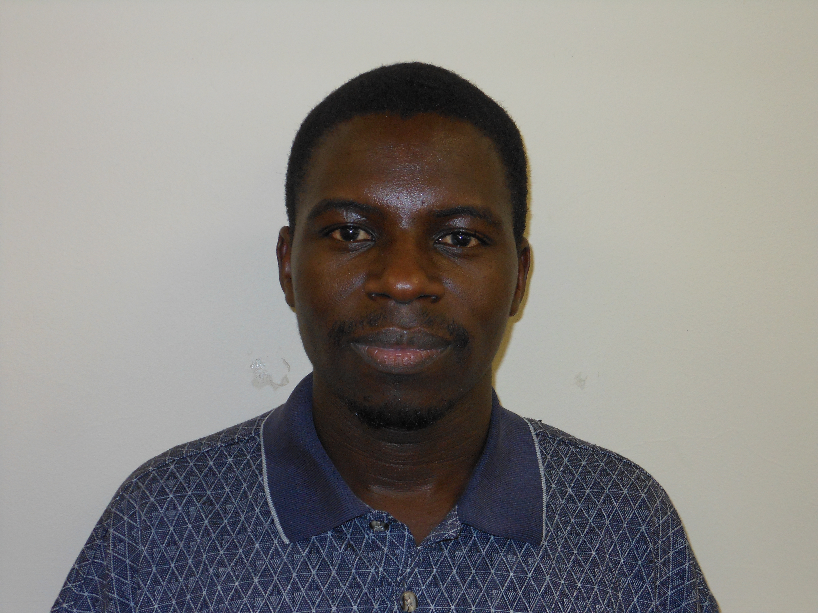
Nickson M. Karie received the BSc degree with honors in Information Technology from Kurukshetra University (India) in 2005 and MSc degree in 2007 from Sikkim Manipal University of Health and Technological Sciences (India). Currently, Nickson is a PhD Computer Science student at the University of Pretoria South Africa focusing on Digital Forensics. He has published a number of papers both in International Conferences and scientific Journals.

